**Pre-Requisites - JSON PATH**

In the upcoming lecture we will explore some advanced commands with kubectl utility. But that requires JSON PATH. If you are new to JSON PATH queries get introduced to it first by going through the lectures and practice tests available here.

<https://kodekloud.com/p/json-path-quiz>

Once you are comfortable head back here:

I also have some JSON PATH exercises with Kubernetes Data Objects. Make sure you go through these:

<https://mmumshad.github.io/json-path-quiz/index.html#!/?questions=questionskub1>

<https://mmumshad.github.io/json-path-quiz/index.html#!/?questions=questionskub2>

**Introduction to YAML**

-Use to represent the configuration data

- Human friendly data serialization standard for all programming language

- Syntax : strict indentation

- Store the config file with your code or own git repository ( as IaC)

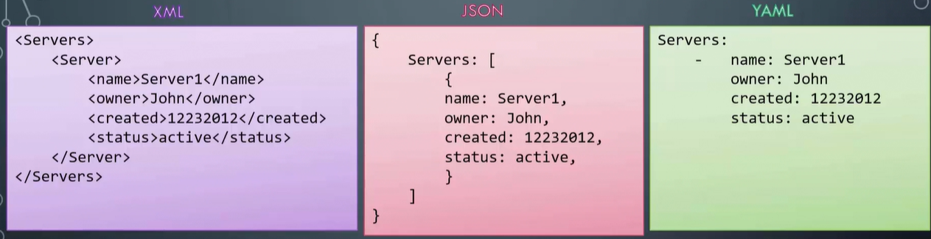

* It consists with key value pair
* Need a space right after colon and before the value
* The array lists the elements under it
* Dash(-) indicates an element of an array
* The dictionary is a set of properties grouped together under an item. Before each properties of single item must be aligned with equal number of spaces.

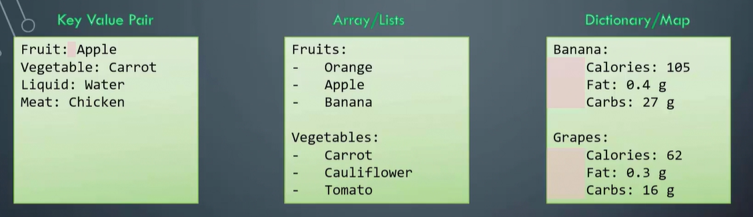

* Spaces defines in item should be syntactically aligned to represent properties of single item.

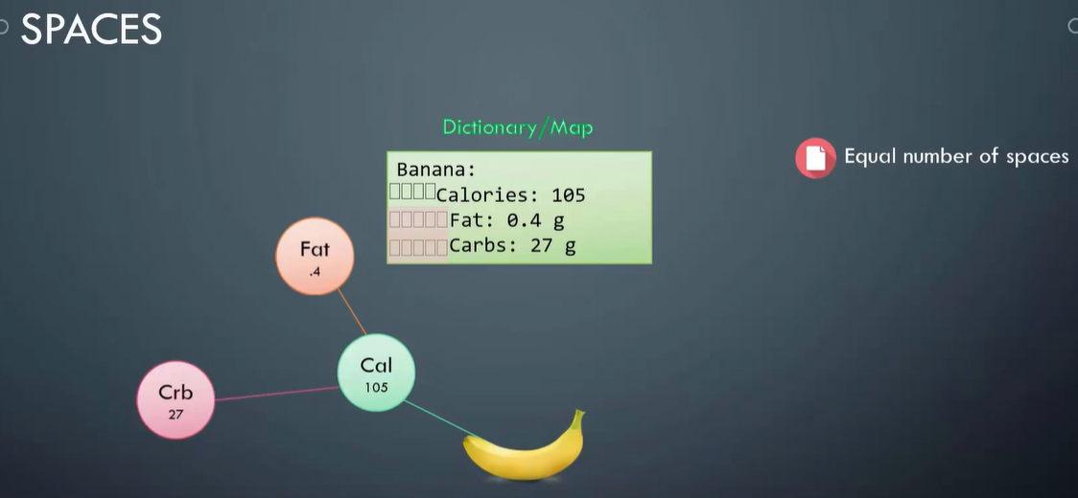

* You can have lists containing dictionaries containing lists

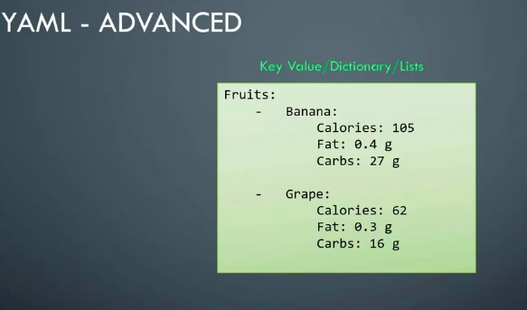

* Dictionary: To store different information or properties of a single object. Properties are defined in key-value format

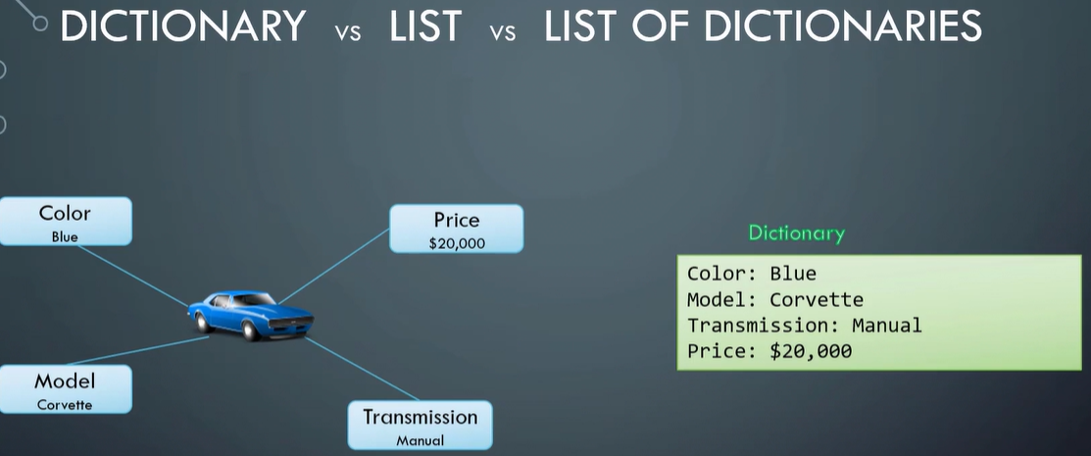

* Dictionary In Dictionary

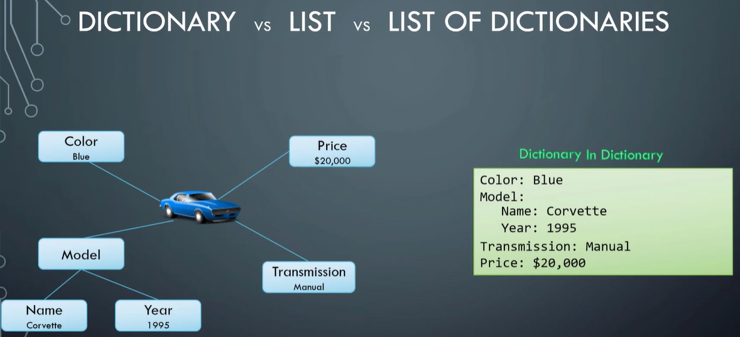

dvbvnhgjy

* List: To represent multiple items of the same type of object

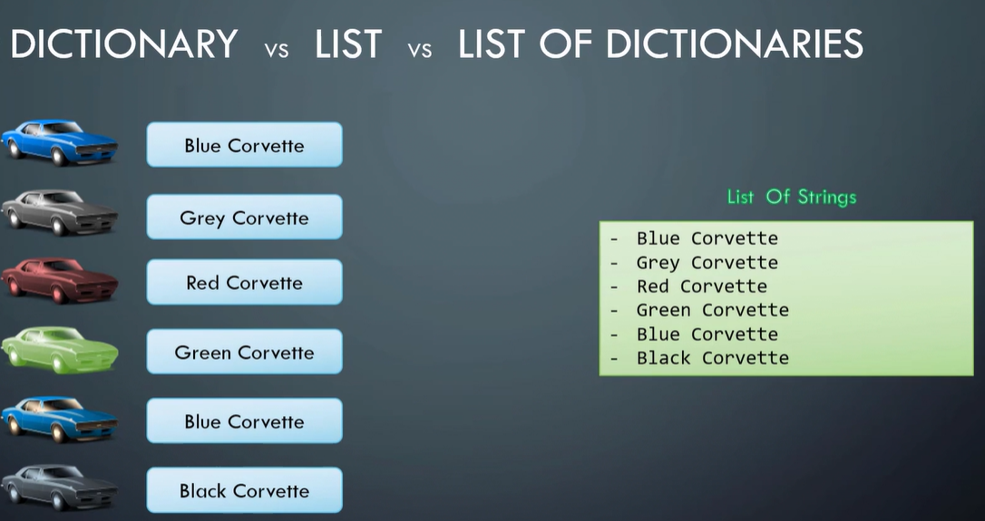

* List of dictionaries: Expand each item in the list and replace the name with dictionary

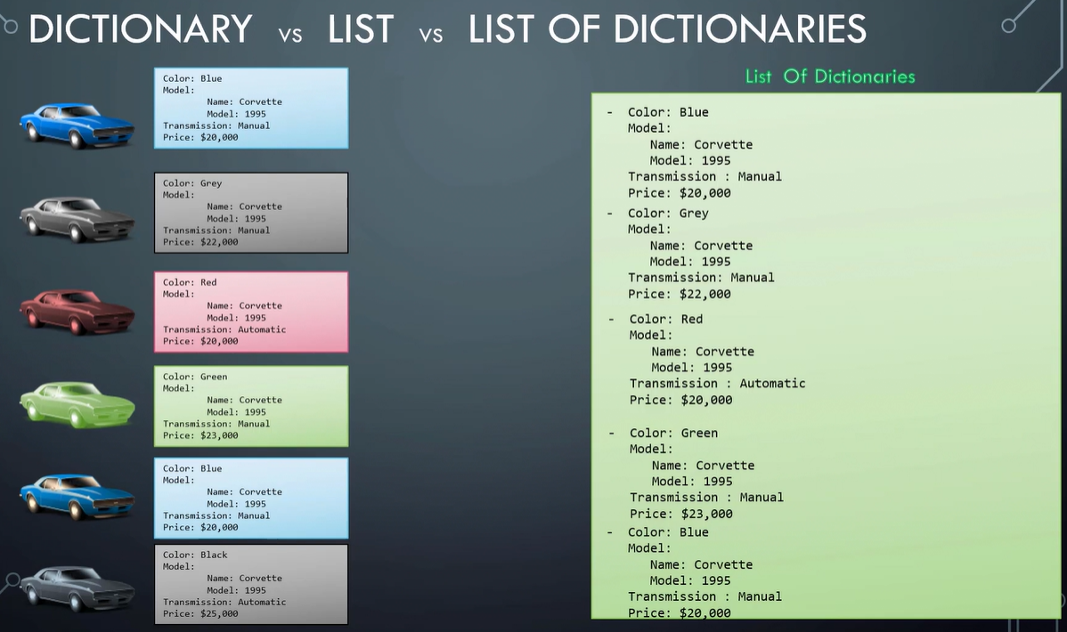

* Dictionary is unordered collection, arrays are ordered collection

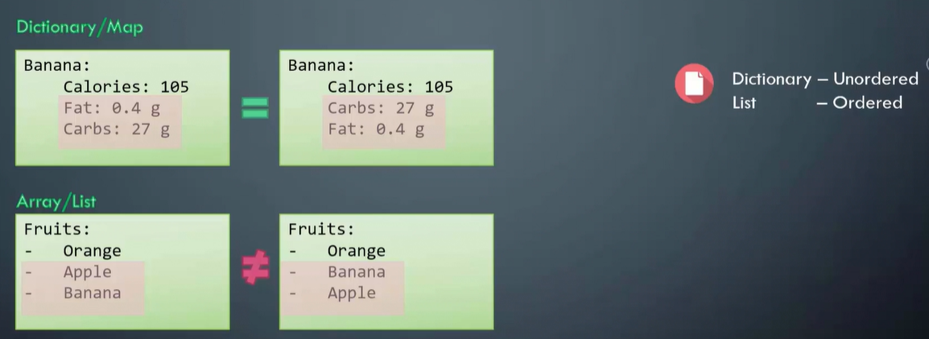

* Any line begin with # is considered as comment

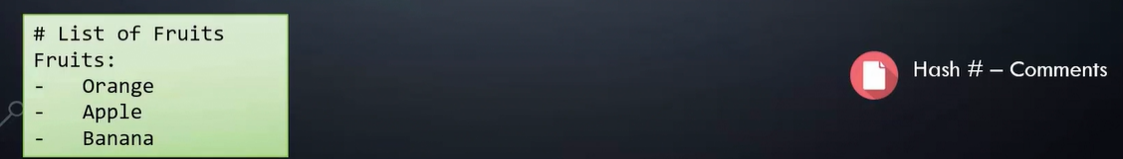

**Introduction to JSON PATH**

***YAML vs JSON***

-YAML uses indentation to organize data into lists and dictionaries, JSON uses braces or curly brackets

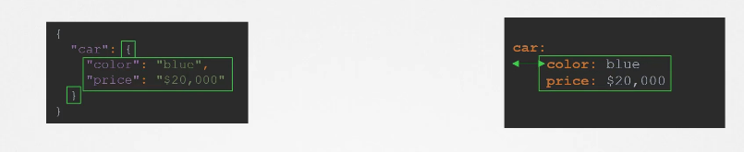

-YAML uses dash to denote an item in a list, JSON uses square brackets to define a list and each item within the list is separated by comma.

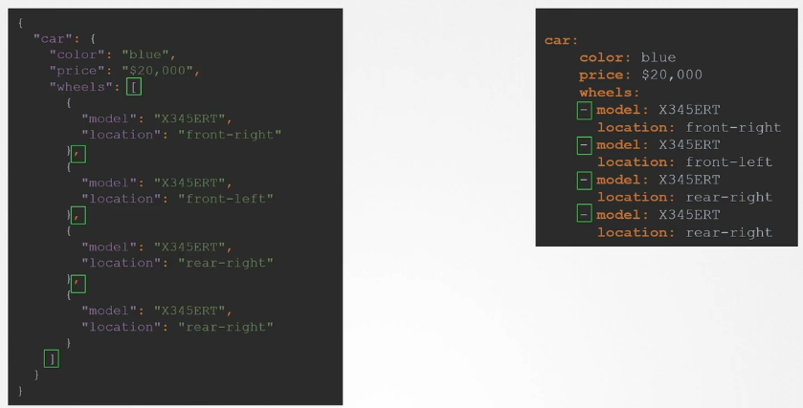

-You can easily convert data in YAML to JSON or JSON to YAML using online converter(https://www.json2yaml.com) or a simple program.

-All programming language have support for reading and writing in either of JSON or YAML format.

***JSON PATH***

-JSON path is query language that can help you parse data represented in a JSON or YAML, like query languages in popular database software SQL. You apply query and get result which subset of data. For example, if you have given table of data, run query against it and extract certain fields or rows

*Query with SQL*

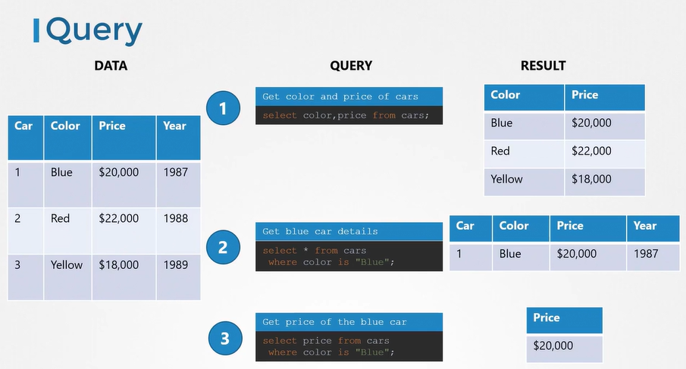

*Query with JSON PATH*

***JSON PATH - Dictionaries***

-The dot notation in the query helps you select a particular field within a dictionary. car.price

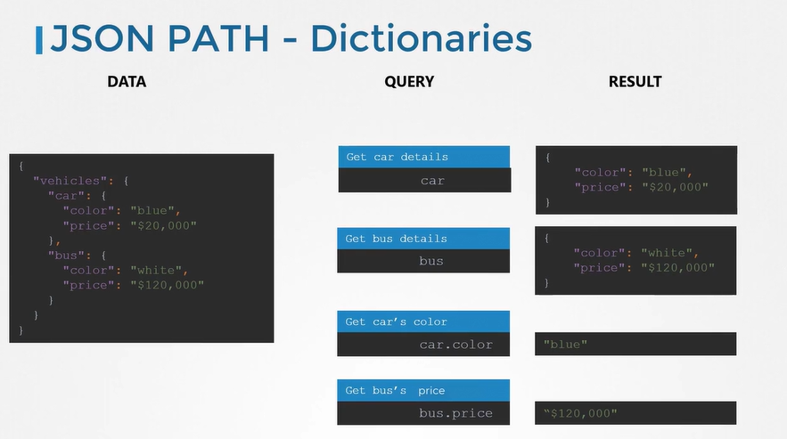

-Suppose we encapsulated few child dictionaries into parent dictionary. Extract properties of dictionaries and dictionaries of dictionaries with dot notation. Here querying data in this way won't work.

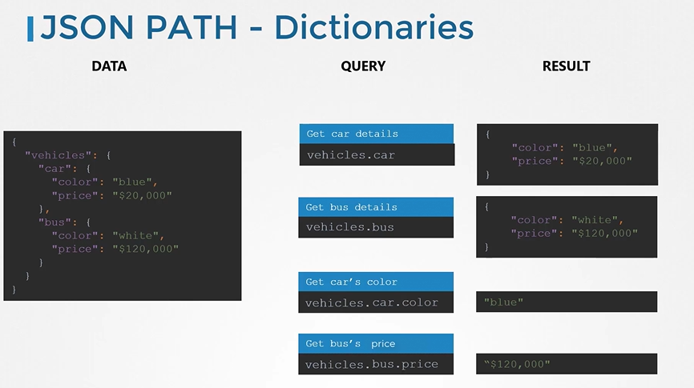

Let's remove vehicles as parent dictionary and see car and bus are properties of parent dictionary. The top-level dictionary has no name is known as the root element of a JSON document. The root element is denoted by a dollar $. A query created for JSON document with a dictionary at its root start with dollar $

JSON PATH query : $.car

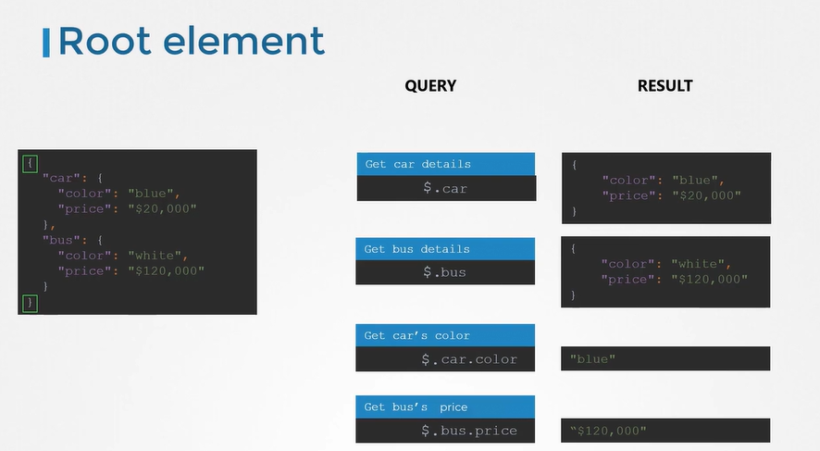

If you add vehicles as parent dictionary, query data with root element.

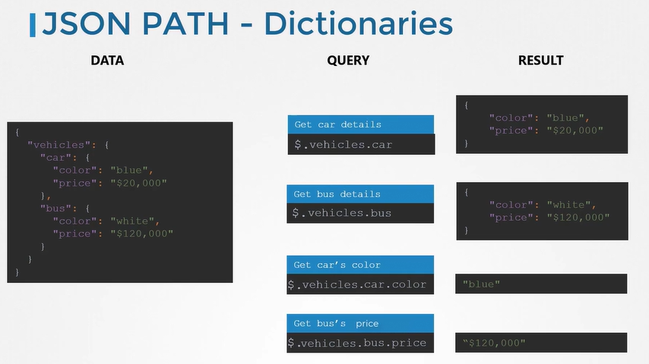

Even though the result you see here is what you expect, all results of JSON path query are encapsulated within an array like within pair of square bracket.

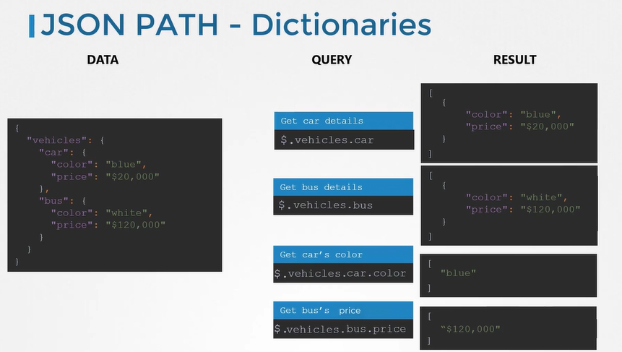

***JSON PATH - Lists***

The list here is names of different vehicles. Query with root element $ mark. Use square bracket in your query and specify the position of the item you want inside it. The indexes start at zero. Thus first element is at zero, second one is at one, the third one is at two, etc.

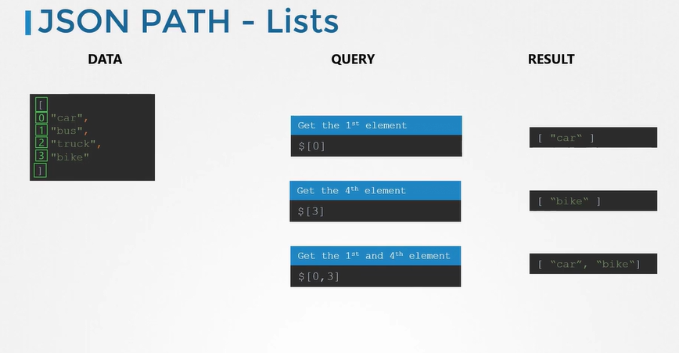

alpine-host ~ ➜ cat q13.json | jpath $[0,3]

[

"bike"

]

alpine-host ~ ➜ cat q13.json | jpath '$[0,3]'

[

"car",

"bike"

]

***JSON PATH - Dictionary & Lists***

To get the model of the 2nd wheel

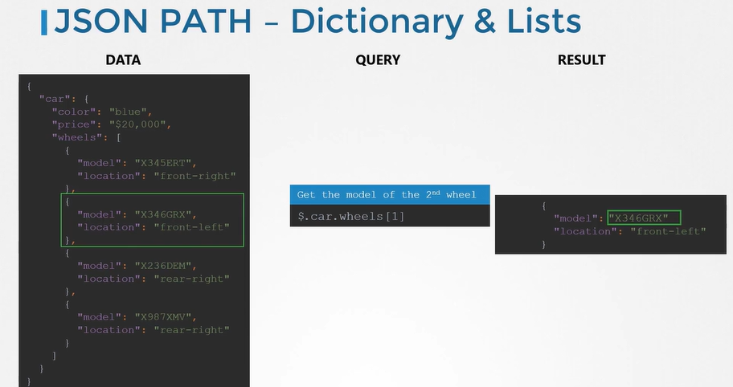

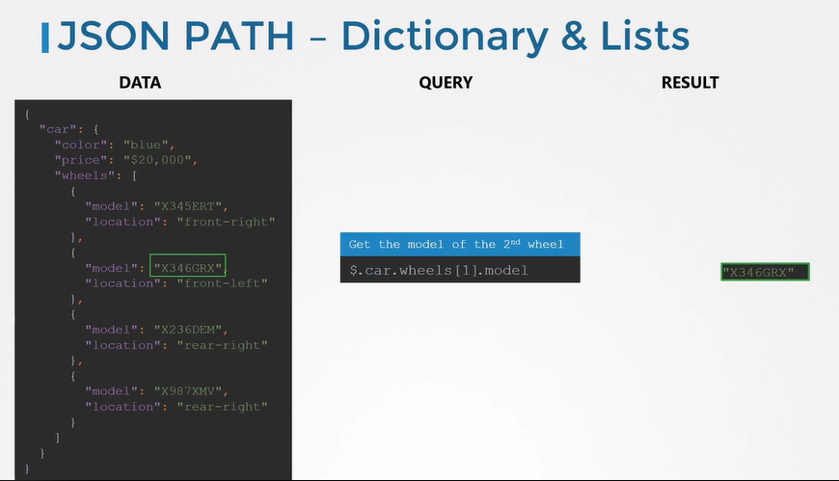

***JSON PATH - Criteria***

Apply criteria or conditions to query. As example, get all numbers greater than 40.

In this case. There could be thousands of numbers within the square brackets. So check if each item in the array is greater than 40.

$[ Check if each item in the array > 40 ]

Check if -> ? ()

The "check if " part can be replaced by a question mark, followed by pair of brackets.

$[ ? ( each item in the array > 40 )]

each item in the list -> @

$[ ? ( @ > 40 )]

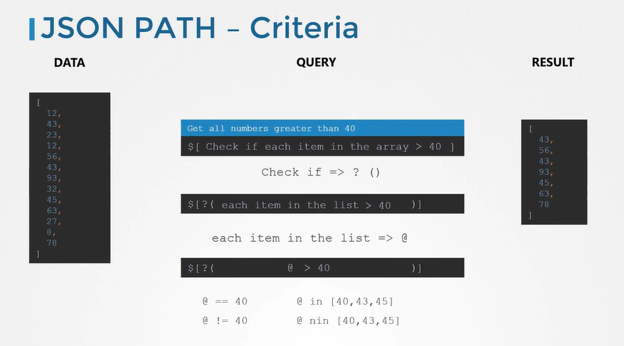

Other operators;

@ == 40 ; equal to 40 each item in the list

@ != 40 ; not equal to 40 each item in the list

@ in [40,43,45] ; numbers either 40,43,45 from each item in the list

@ nin [40,43,45] ; numbers are not either 40,43,45 from each item in the list

Let see how criteria should define to list of dictionaries.

Get the model of rear-light wheel

$.car.wheels[2].model

We can't rely on hardcoded item in the list. Use the criteria to get model of rear-light wheel if it is any position in the list.

$.car.wheels[?(@.location == "rear-light")].model

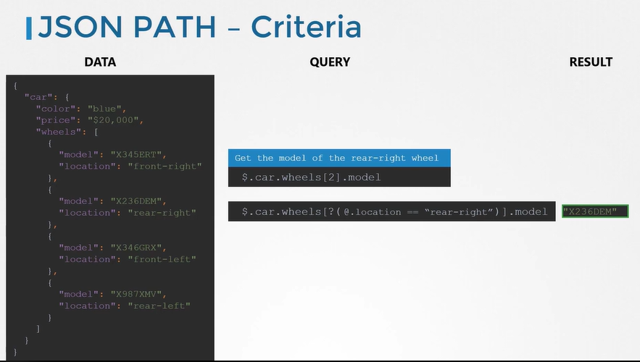

References

<https://github.com/json-path/JsonPath>

Use keyword jpath to query from JSON file.

alpine-host ~ ➜ cat q1.json | jpath $.property1

[

"value1"

]

*JSON PATH query for list of lists*

alpine-host ~ ➜ cat q11.json | jpath $.prizes[5].laureates[1]

[

{

"id": "914",

"firstname": "Malala",

"surname": "Yousafzai",

"motivation": "\"for their struggle against the suppression of children and young people and for the right of all children to education\"",

"share": "2"

}

]

**JSON PATH - Wildcard**

*JSON PATH - Wildcard - Dictionary*

To query values of specific property in the dictionary, use star * for wildcard meaning all or any.

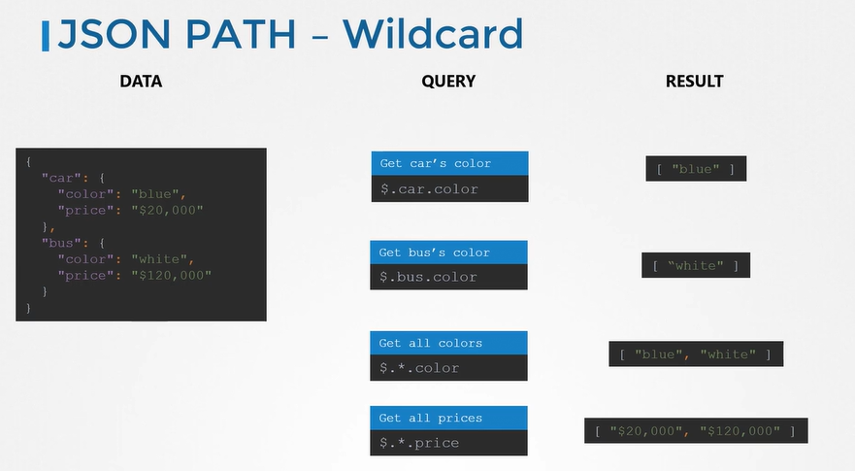

*JSON PATH - Wildcard - List of Dictionaries*

Similarly, use star * or wildcard meaning all or any to query values of specific property in the list of dictionaries.

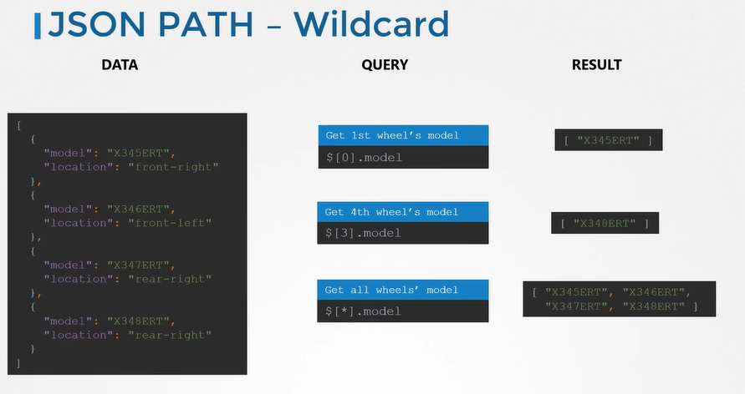

alpine-host ~ ✖ cat q4.json | jpath '$[*].model'

[

"KDJ39848T",

"MDJ39485DK",

"KCMDD3435K",

"JJDH34234KK"

]

*JSON PATH - Wildcard - List & Dictionaries*

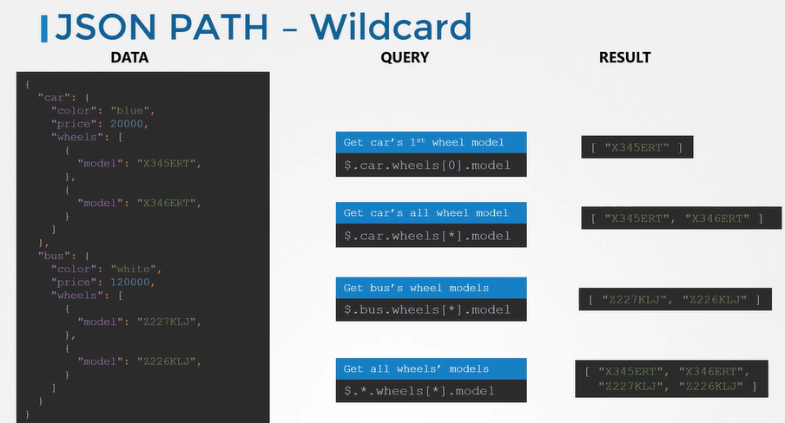

alpine-host ~ ➜ cat q5.json | jpath $.car.wheels[*].model

[

"KDJ39848T",

"MDJ39485DK",

"KCMDD3435K",

"JJDH34234KK"

]

alpine-host ~ ➜ cat q8.json | jpath $.prizes.[*].laureates[*].firstname

Error: Parse error on line 1:

$.prizes.[*].laureates[*].fir

---------^

Expecting 'STAR', 'IDENTIFIER', 'SCRIPT_EXPRESSION', 'INTEGER', 'END', got '['

at Parser.parseError (/usr/local/lib/node_modules/jsonpath-cli/node_modules/jsonpath/generated/parser.js:166:15)

at Parser.parser.yy.parseError (/usr/local/lib/node_modules/jsonpath-cli/node_modules/jsonpath/lib/parser.js:13:17)

at Parser.parse (/usr/local/lib/node_modules/jsonpath-cli/node_modules/jsonpath/generated/parser.js:224:22)

at JSONPath.nodes (/usr/local/lib/node_modules/jsonpath-cli/node_modules/jsonpath/lib/index.js:118:26)

at JSONPath.query (/usr/local/lib/node_modules/jsonpath-cli/node_modules/jsonpath/lib/index.js:94:22)

at query (/usr/local/lib/node_modules/jsonpath-cli/bin/index.js:16:29)

at process.processTicksAndRejections (node:internal/process/task_queues:95:5)

If this error comes, put the expression into single quote '<expression>'

alpine-host ~ ➜ cat q8.json | jpath '$.prizes[*].laureates[*].firstname'

[

"Arthur",

"Gérard",

"Donna",

"Frances H.",

"George P.",

"Sir Gregory P.",

"James P.",

"Tasuku",

"Denis",

"Nadia",

"William D.",

"Paul M.",

"Kailash",

"Malala",

"Rainer",

"Barry C.",

"Kip S.",

"Jacques",

"Joachim",

"Richard",

"Jeffrey C.",

"Michael",

"Michael W."

]

**JSON PATH - Lists**

Let's look through additional options in lists.

If you want to get all names from the first to the fourth element, use "colon"

$[0:3]

START:END

However, this will not show fourth element itself. If you want to include fourth element as well, you should say zero to four.

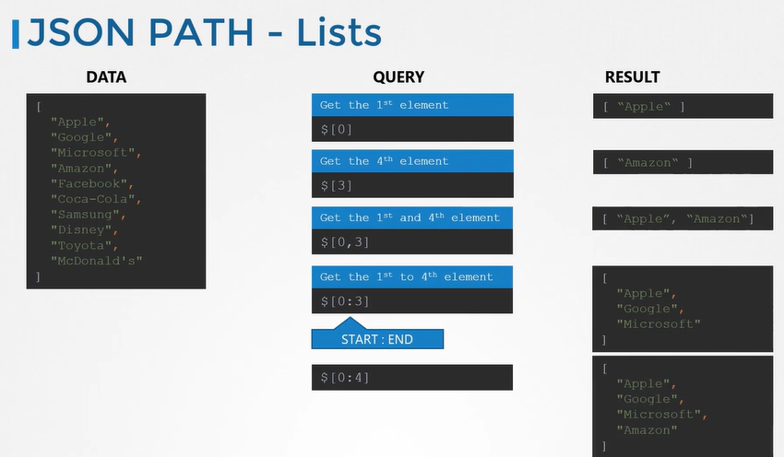

If we want to get every other item, use the step option by adding another colon and specifying the number of hubs to take after each item. A step value two means increment the counter twice before fetching the next item.

$[0:8:2]

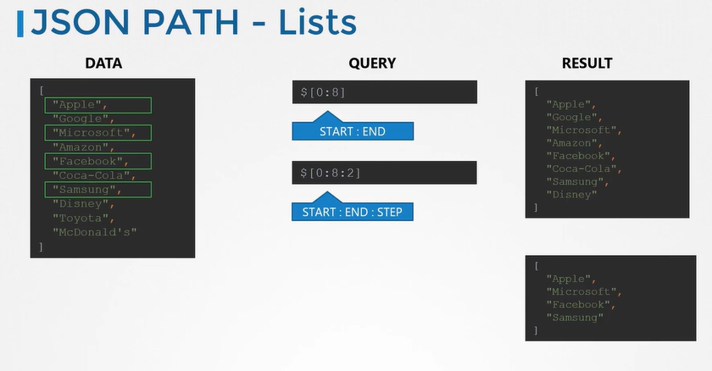

If you want query and return the last item in a list when the number of items in list is larger. Like how you have indexes starting at zero from first item in a list, you also have indexes start at minus one from the last item in the list. The last item is always at minus one.

$[-1] ; But this does not work in certain implementations

$[-1:0] or $[-1:] ; Get the last element

$[-3:] ; Get the last 3 elements

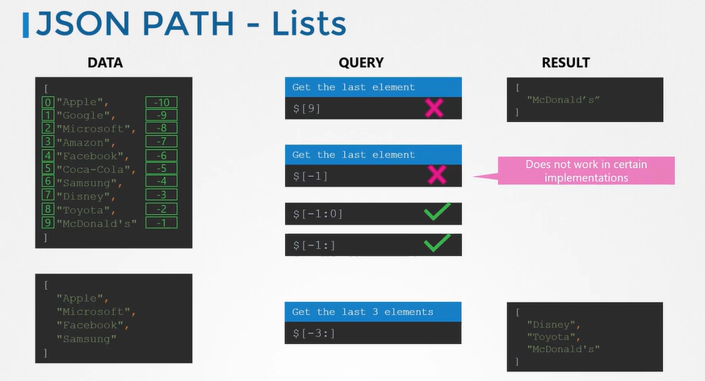

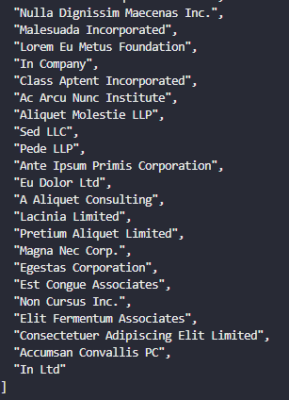

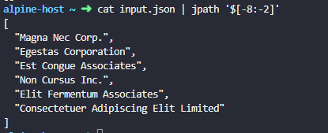

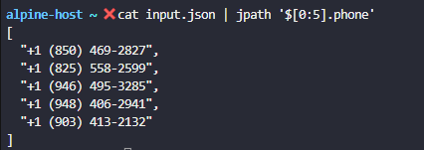

**JSON PATH Use case - Kubernetes**

***Why JSON PATH?***

We focus how to use JSON path queries with the kubectl utility.

When you are working with production environment for Kubernetes, you will need to view information about hundreds of nodes and thousands of pods, deployments, replicasets, services and secrets. You use kubectl utility to view information about these objects.

You will often have requirements to print summary of different states about different resource, view specific fields of all resources, query data about resources based on different criteria. Viewing such information going through thousands of resources is overwhelming task. This is why kubectl supports JSON PATH option to make filtering data across large data set using complex criteria.

***KubeCtl***

Kubectl utility is Kubernetes CLI that use for reading and writing Kubernetes objects. When you run kubectl command, it interacts with Kubernetes API through Kube-apiserver.

The Kube-apiserver speaks JSON language, so it returns the requested information in JSON format. The kubectl utility on receiving the information in JSON fomat converts it into a human-readable format and prints it out to our screen. During that process, a lot information came in JSON format is hidden to make the output readable by showing only the necessary details.

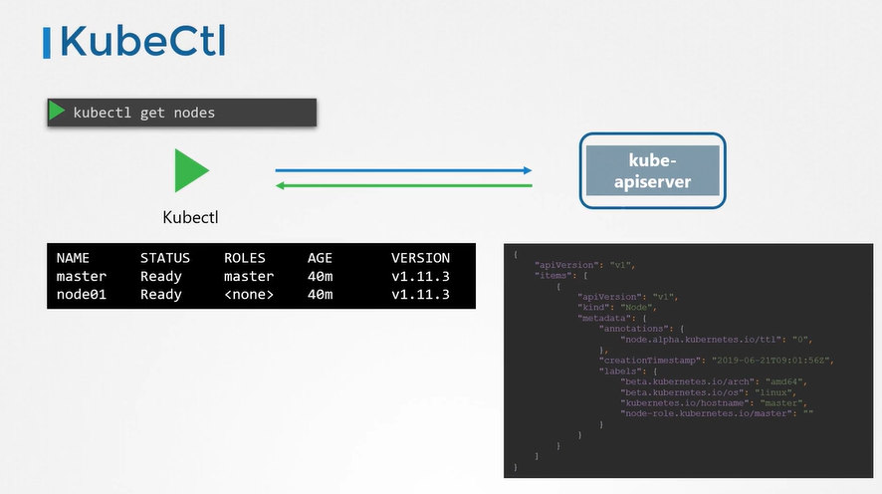

If you need additional details, use **-o wide** option with kubectl get command. But this is still not complete output. For example, the resource capacity available on nodes, taint set on nodes, conditions on node, the hardware architecture, container image available on nodes are lot more details that are not part of this output. But these data can see by running **kubectl describe** command.

***KubeCtl - JSON PATH***

What if you want to see the data in a tableau format like a report for node's CPU count, list of nodes, taint set on nodes, the architecture on node, list of pods and images they use. None of the built-in commands can give these in this format. That's where JSON PATH queries can help to filter and format the output of a command as you like.

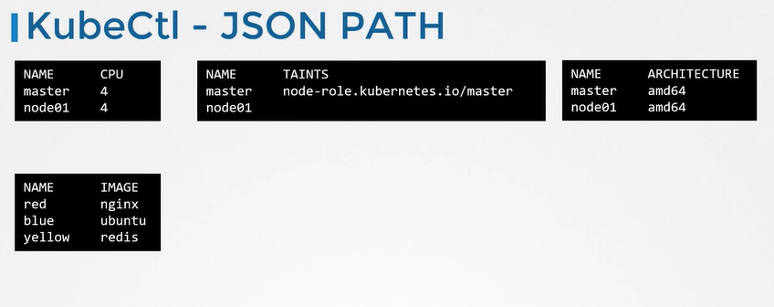

***How to JSON PATH in KubeCtl?***

1. Identify the kubectl command - What commands give you the required information in the raw format such as kubectl get nodes, kubectl get pods
2. Familiarize with JSON output - Inspect its output in JSON format. Add the option -o json to the command to print output in a JSON format
3. Form the JSON PATH query - Look output of JSON document and form the JSON PATH query that will retrieve the required information. The root element '$' is not mandatory. Kubectl adds it.

.items[0].spec.containers[0].image

1. Use the JSON PATH query with kubectl command - To do that , use the **-o=jsonpath=** option and pass the same JSON PATH query. You must encapsulate the JSON PATH query within pair of single quotes and curly braces.

**kubectl get pods -o=jsonpath= '{.items[0].spec.containers[0].image}'**

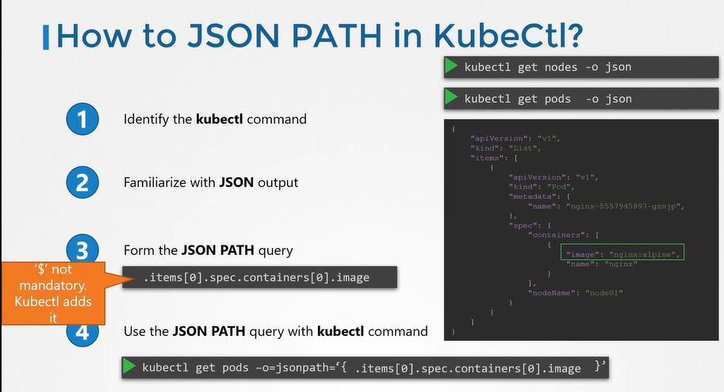

You may use JSON PATH query evaluator like jsonpath.com to play around with it until you come up with right JSON path query.

When you merge multiple JSON PATH query, use {"\n"} for New line, {"\t"} for Tab to arrange the output.

kubectl get nodes -o=jsonpath='{.items[*].metadata.name} {"\n"} {.items[*].status.capacity.cpu}'

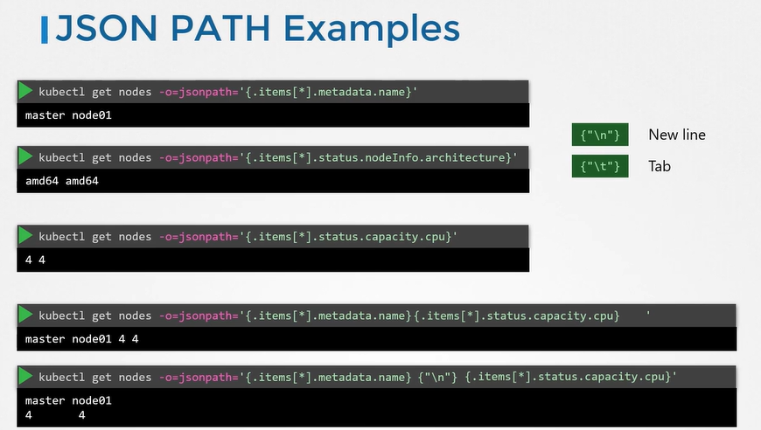

***Loops -Range***

To get node name in one column and CPU counts in other column. This is where we use loops to iterate through items in a list and print properties of each item.

To specify the for each statement, use the **range** keyword.

For each item or a node, print the node name, then insert a tab as a separator, then print the CPU count, followed by a new line character. Finally **end** the loop using the end keyword.

**kubectl get nodes -o=jsonpath='{range .items[*]} {.metadata.name} {"\t"} {.status.capacity.cpu} {"\n"} {end}'**

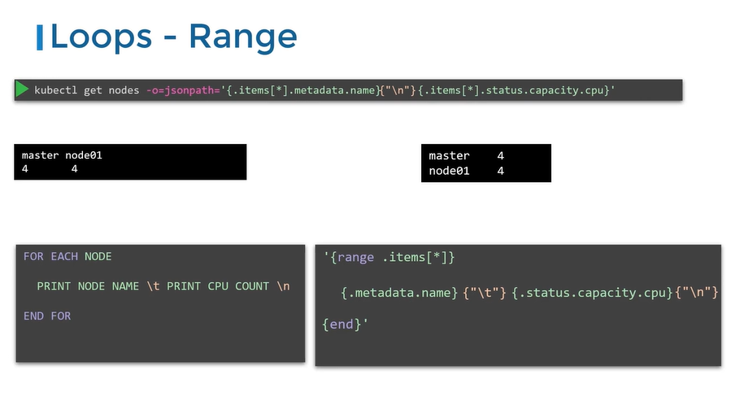

Merge it all in into a single line and pass it as a parameter.

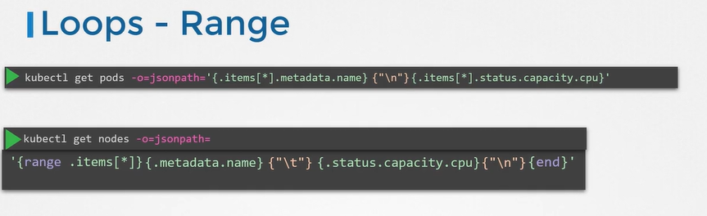

***JSON PATH for Custom Columns***

This is an easier approach when compare to using the loop method. We use JSON PATH option to print node name and CPU capacities as separate columns.

**kubectl get nodes -o=custom-columns=<COLUMN NAME>:<JSON PATH>**

**kubectl get nodes -o=custom-columns=NODE:.metadata.name ,CPU:.status.capacity.cpu**

Note that you must exclude the item section of the query as the custom-columns assumes the query is for each item in the list. Similarly you can add additional column and JSON PATH pairs separated by a comma. custom-columns option doesn't need '{}'

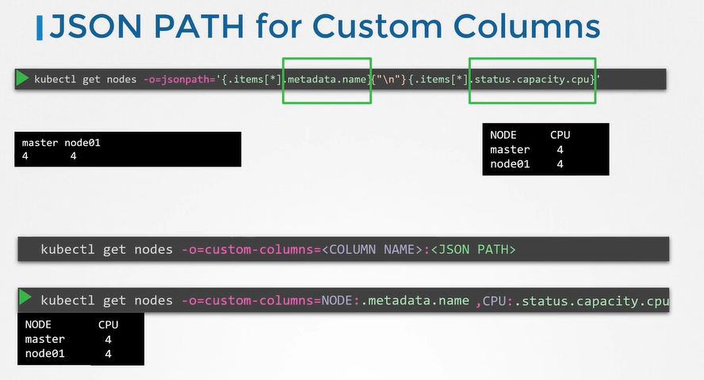

***JSON PATH for Sort***

JSON PATH can use while sorting objects by specifying the sort by option where sort the output based on value of a property from the JSON formatted properties of each item. Sort-by option doesn't need '{}'

**kubectl get nodes --sort-by= .metadata.name**

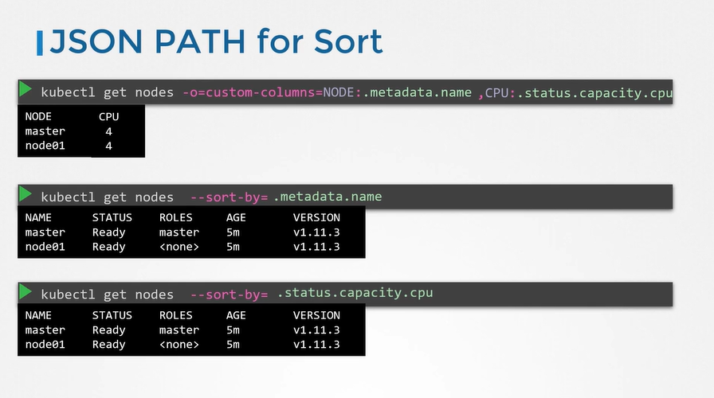

controlplane ~ ➜ kubectl get nodes -o=jsonpath='{.items[*].status.nodeInfo.osImage}'

Ubuntu 22.04.5 LTS Ubuntu 22.04.5 LTS

kubectl config view --kubeconfig=/root/my-kube-config ; To query kubeconfig file with -o=jsonpath even though the output is not json



